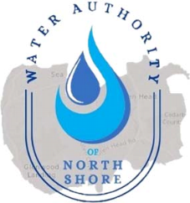
WATER AUTHORITY OF NORTH SHORE

MEETING SCHEDULED FOR JANUARY 26, 2026 IS CANCELED.

PLEASE CHECK BACK ON THE WEBSITE FOR NEXT MEETING ANNOUNCEMENT.

